Around the World with RCA International Story Shares

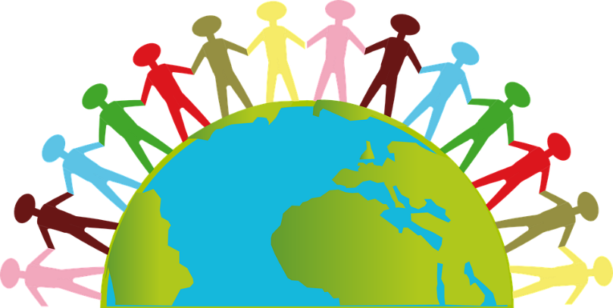
Click Here for the RCA Web Page
Find this meeting on the RCA website, go to ‘meetings’ page and type in the keyword ‘International’
This is a story share meeting that occurs on the first Saturday of the month. Come listen to the amazing, success stories of our members.
Saturday, September 5, 2020 – Felicita and Richard; Davis, California
Saturday, October 3, 2020 – Rebecca and Barton; Santa Barbara, California
Saturday, November 7, 2020 – Mary Monica and Scott; Missouri
Saturday, December 5, 2020 – Andrea and Brad; Boulder, Colorado
Saturday, January 2, 2021 – Jen and Dave;
Saturday, February 6, 2021 – David and Kapiko, Burbank, California
Saturday, March 6, 2021 – Beatrice and Theodor; Sweden
Saturday, April 3, 2021
Saturday, May 1, 2021
Saturday, June 5, 2021
Saturday, July 3, 2021
Saturday, August 7, 2021
Saturday, September 4, 2021
Saturday, October 2, 2021
Saturday, November 6, 2021 – Ced and Aravin, France, United Kingdom
Saturday, December 4, 2021

The time of this meeting is 2 PM Eastern

To figure out your time zone, please visit this link and put in your location: World Time Buddy

Join by ZOOM https://zoom.us/j/635585096

One tap mobile
+16699006833, 635585096# US (San Jose)
+16465588656, 635585096# US (New York)
Dial by your location
+1 669 900 6833 US (San Jose)
+1 646 558 8656 US (New York)
Meeting ID: 635 585 096
Find your local number: https://zoom.us/u/aiuaRRTbn

Previous Speakers:
March 2, 2019 – Andy and Steve; Pahoa, Hawaii
April 6, 2019 – Annette and Widar; Copenhagen, Denmark
May 4, 2019 – Gladys and Jade; Eugene, Oregon
June 1, 2019 – Christiane and Roberto; Frankfurt, Germany
July 6, 2019 – Kathleen and David; Alameda, California
August 3, 2019 – no speaker due to the Portland, RCA Convention
September 7, 2019 – Annie and Russ; Calgary, Alberta, Canada
October 5, 2019 – Dixie and David; Longwood, Florida
November 2, 2019 – Mary and Phil; Tucson, Arizona
December 7, 2019 – Cathy and Scott; Edmonton, Alberta, Canada
January 4, 2020 – Sunny and Steve; Reston, Virginia
February 1, 2020 – Vicki and Dick; Palm Desert, California
March 7, 2020 – Niki and Michael; Boulder, Colorado
April 4, 2020 – Linda and Brian; Walnut Creek, California
May 2, 2020 – Beth and Benji; Memphis, Tennessee
June 6, 2020 – Kate and Dan; Gaithersburg, Maryland
Saturday, July 4, 2020 – Sara and Megan; Tucson, Arizona
Saturday, August 1, 2020 – Donna and Gary; Fairfax, Virginia

